

(英文题目， Times New Roman小一号加粗，居中)
The Design and Implementation of TTCN-3 Compiler Based on an Intermediate Language

By
(作者姓名，例：Zhang Weihua，注意格式)
Zhang Hongbin
Supervisor: （导师姓名）
Chen Juncheng

Submitted to the Fan Gongxiu Honors College，BJUT
in Partial Fulfillment of Requirements for
the Degree of Bachelor of Engineering in Computer Science
Beijing University of Technology

Beijing, China
June, 2019

（本页不标注页码）
独 创 性 声 明
本人声明所呈交的论文是我个人在导师指导下进行的研究工作及取得的研究成果。尽我所知，除了文中特别加以标注和致谢的地方外，论文中不包含其他人已经发表或撰写过的研究成果，也不包含为获得北京工业大学或其它教育机构的学位或证书而使用过的材料。与我一同工作的同志对本研究所做的任何贡献均已在论文中作了明确的说明并表示了谢意。

签名： 日期：

关于论文使用授权的说明

本人完全了解北京工业大学有关保留、使用学位论文的规定，即：学校有权保留送交论文的复印件，允许论文被查阅和借阅；学校可以公布论文的全部或部分内容，可以采用影印、缩印或其他复制手段保存论文。
（保密的论文在解密后应遵守此规定）

签名： 导师签名： 日期：

（本页不标注页码）

Abstract （单独一页）
[Times New Roman三号加粗，居中]
[正文Times New Roman小四，行距固定值23磅]
[英文摘要正文400词左右]

（摘要正文后空一行写英文关键词）
Key words: (整行Times New Roman小四加粗；关键词之间用分号最后一个后面不用分号；关键词为3-5个；非专有名词首字母不大写）

Abstract
Testing and Test Control Notation version 3 (TTCN-3) is a strongly typed testing language used in conformance testing of communicating system. Although there are compilers for TTCN-3 based on java and C++, the ability of concurrency is still a problem. The paper introduces the TTCN-3 compiler based on Go language. The workflow of the compiler can be separated into four phases: lexical analysis, syntax analysis, semantic analysis and translation. To make the compiler work well, the project uses ANTLR to enhance the performance of lexical and syntax analyzer, uses a powerful symbol table to guarantee the correctness of semantic phase and formulate a translate scheme to realize the output. Under the support of ANTLR and Go Language, TTCN-3 compiler can build parser tree, enforce static typing rules and generate Go language in a high efficiency.

Contents (Times New Roman三号加粗居中) （单独一至两页）

例：

Chapter 1 Introduction（一级标题Times New Roman四号；序数顶格，后空两格写标题） 1
Chapter 2 The Brief Introduction to the Localized Varieties of English 2
2.1 The Localized Varieties of English（二级标题Times New Roman小四;序数前空两格写，后空两格写标题） 2
2.1.1 English words(三级标题Times New Roman小四;序数前空四格写，后空两格写标题) 2
2.1.2 Chelsea 2
Chapter 3 Conclusion（300－500字） 3
Notes（Times New Roman三号加粗，居中，另起一页） 4
Bibliography （Times New Roman三号加粗，居中，另起一页） 5
Acknowledgements（Times New Roman三号加粗，居中，另起一页） 6

(目录最多可至三级标题；行间距为固定值23磅，Chapter 1 以后用阿拉伯数字标注页码，从1开始)

正文样本：

Chapter 1 Introduction（另起一页）

[一级标题居中，Times New Roman，三号加粗；首词及实词首字母大写]
[正文用Times New Roman小四,正文每段开始空两个字符（两个汉字或4个英文字母），行距固定值23磅]
[一级标题后各空一行写二级标题，但二级标题若在页首首行则二级标题前不空行]
[从此处开始编页码，用阿拉伯数字（起始页码：1）；页码（Times New Roman五号）居中标在页面底端]

Chapter 2 The Brief Introduction to the Localized Varieties of English

2.1 The Localized Varieties of English
[二级标题序数顶格写，标题序数后空一格写标题，末尾不加标点；Times New Roman，四号加粗；首词及实词首字母大写；标题前空一行，但若在页首首行则标题前不空行]

2.1.1 English words
[三级标题序数空四个字母或两个汉字写，标题序数后空一格写标题，末尾不加标点；Times New Roman，小四号加粗；第一个单词首字母大写]

2.1.1.1 Chelsea
[四级标题序数空四个字母写，标题序数后空一格写标题，末尾不加标点；Times New Roman，小四加粗；第一个单词首字母大写]

Chapter 2 Lexical analysis

Chapter 3 Syntax analysis

Chapter 4 Semantic analysis
After lexical analysis and syntax analysis, the parser tree has been built. It seems like the compiler is ready for the translation. While, we should make sure the symbols of the program are used correctly. In this case, what we need is a semantic analyzer. The semantic analysis phase of a compiler connects variable definitions to their uses, checks that each expression has a correct type. The key to implementing this phase is an appropriate data structure called a symbol table. Our application will store symbols in the symbol table and then check identifier references for correctness by looking them up in the symbol table.

4.1 Symbol Table
Symbol table is data structure that used by compiler to hold information about source program constructions. TTCN-3 allows the same identifier to mean different things in different contexts. Thus, the symbol table groups symbols into scopes. A scope is just a set of symbols such as a list of parameters for a function or the list of variables and functions in a global scope.
In this project, we use the scope tree and hash map to realize the data structure of the symbol table. Scope tree show the relationship between the scopes of a program and each scope holds the symbols which are defined in the corresponding scope. Hash map is used to store the symbols because it can offer the efficient insert and read ability.
For example, the following program is an illustration to show the structure of the symbol table.
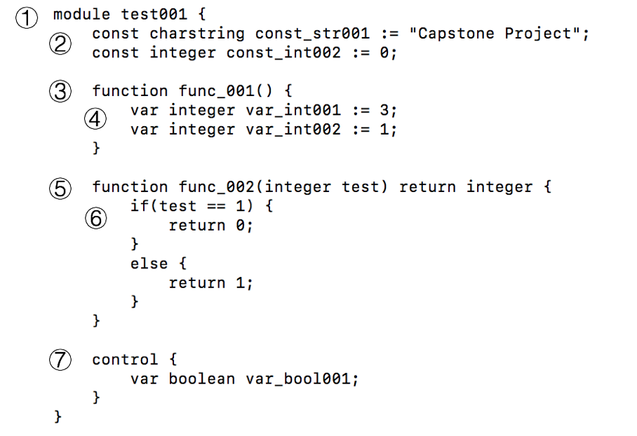
Figure 4-1 Example program
In this program, there are seven scopes. At the very beginning, the global scope is defined, which hold two constants (const_str001 and const_int002), two function definitions ( func_001 and func_002) and a control scope. Functions are visible in the global scope, and they also constitute new scopes called function scopes, which contain the parameters of the function. The local scope helps function definition handle the variables defined into the function definition. And control parts of the TTCN-3 program are included in the control scope. All the scopes are formed as a tree showed below.
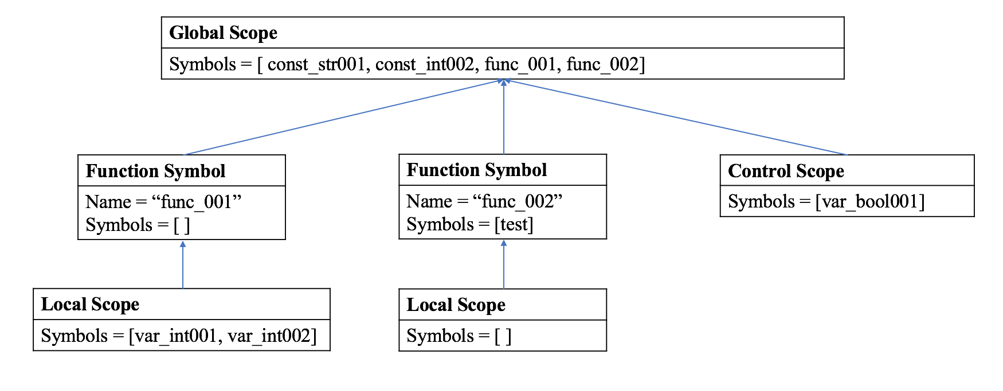
Figure 4-2 Scope tree
Then came the hash map, we use hash map to store the symbols of a scope. Considering the order of some symbol like function parameters and record fields have special meanings, we choose the Java LinkedHashMap as the container of those symbols. Because Java LinkedHashMap is a efficient data structure for inserting and reading data, with a predictable iteration. The key-value pair of hash map is <String, Symbol>. In this case, we can define and look up for a symbol with its name.
All the TTCN-3 language elements can be classified as three types: symbol, scope and symbol + scope.
Symbol node represents those language elements who can be defined into a scope. Symbol class has an enumeration type named Type, which used to offer the built-in types. A symbol should have a name and type. Meanwhile, it should know what scope contains it. Thus, there are three member variables, name, type and scope, to realize the characteristics. Besides, a symbol instance can also return the name and print the information with its member methods. And the symbol class can be extended to realize different symbol definition.
As for the scope node, it offers a space for symbols to live in. There are different scope classes for different scope nodes. All the scope nodes should implement the Scope interface, which offers the following methods:
- getScopeName method is used to return the name of the scope. The return type is String.
- getEnclosingScope method is used to get enclosing scope, which can support the pop method of the scope stack. The method will return a Scope type.
- define method is used to define a symbol into the current scope. The argument is a Symbol instance.
- resolve method is used to look up name in the current scope or in enclosing scopes. The argument is a String type name and the return type is Symbol instance.
Apart from that, for each scope node, there is a pointer points to the enclosing scope and there is a hash map to hold the symbols which belong to the scope. At the very beginning of the semantic analysis, we should define a global scope for the module, and any other scopes will be defined under the global scope.
Besides, there is a special type symbol + scope, which means the element is a symbol and it represents a scope too. A symbol + scope node has all the characteristics of symbol and implements all the methods of the scope interface. It can be defined into the current scope, and the other symbols can also be defined in its scope. For example, as the figure showed below, the function definition is a symbol + scope node, the function definition itself is a symbol of the current scope. In the function scope, the test is defined as a parameter with the integer type.
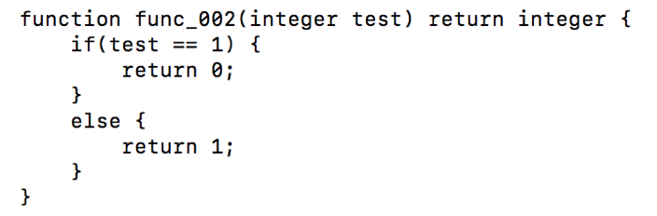
Figure 4-3 symbol + scope example
The symbol table itself is just a repository of symbol definitions—it doesn’t do any checking. To validate code, we need to check the variable and function references in expressions against the rules we set up earlier. There are two fundamental operations for symbol validation: defining symbols and resolving symbols. Defining a symbol means adding it to a scope. Resolving a symbol means figuring out which definition the symbol refers to. In some sense, resolving a symbol means finding the “closest” matching definition. The closest scope is the closest enclosing scope.

4.2 Symbol Binding
With our general strategy, it’s time to build our validator, starting with the DefPhase. Definition phase classes need three fields: a reference to a global scope, a parse tree annotator to track the scopes we create, and a pointer to the current scope.
4.2.1 Variables
Variables can be declared and used in the module control part, test cases, functions and altsteps. A TTCN-3 value variable stores values. It is declared by the var keyword followed by a type identifier and a variable identifier.
A variable instance is a symbol node. In order to define the variables in the current scope, the validator should collect the name and type information of the variable. Then, a variable instance will be constructed with that information and it will be insert into the hash map of current scope by calling define method.
4.2.2 Constants
A constant instance assigns a name to a fixed value. A value is assigned only once to a constant, at the place of its declaration. The constant does not change its value during test execution. The constant is defined only once, but can be referenced multiple times in a TTCN-3 module.
When the walker enters the constDef node, it will check the following element to determine the next action. If the following element is a predefined type, the DefPhase module will bind the predefined type and the constant value name. When it came to the user defined type, the DefPhase will figure out what the user defined type means, then bind the primary type with the constant value name. The binding method is same as variables with the name the type.
4.2.3 Port
Ports facilitate communication between test components and between test components and the test system interface. This project supports the message-based ports. Each port type definition shall have one or more lists indicating the allowed collection of types.
In this project, we treat the port type as the symbol + scope node. When the walker meets the port declaration, the port type will be defined in the current scope, and the scope will hold the types which the port contains.
When a port instance is defined in the component scope, we have to verify the correctness of the port type. In this case, we use the resolve method to look up for the definition of the port type. If the port type exists, the port instance will be defined into the current scope. Otherwise, the semantic analyzer will print the error message to remind the shortness of port declaration.
4.2.4 Component
Component type definitions specify the creation, declaration and initialization of ports and component constants, variables and timers during the creation of an instance of a component type. Every instance of a component type has its own fresh copy of the port, constant, variable and timer instances defined in the component type definition.
Component definition will be defined into the current scope with its name and tCOMPONENT type. Meanwhile, ports instance can live in the component scope. As the port part said above, before defining a port instance into its scope, the component scope should check whether the port type has a correct definition.
4.2.5 Record
TTCN-3 supports ordered structured types known as record. The fields of a record type may be of any TTCN-3 type. The field identifiers are local to the record and shall be unique within the record, but do not have to be globally unique.
The record symbol is a symbol that will be defined into the current scope when the analyzer meets the record definition. Meanwhile, the record symbol also plays a role of scope and fields belong to the record will be defined into the record scope. In this case, we create record field symbol to handle the field elements and define this record field symbols into the hash map of the record scope with the fields’ name.
4.2.6 Function, altstep and testcase
In TTCN-3, functions, altsteps and testcases are used to specify and structure test behaviour, define default behaviour and to structure computation in a module.
- Functions are used in TTCN-3 to express test behaviour, to organize test execution or to structure computation in a module. Functions may return a value and may be parameterized.
- TTCN-3 uses altsteps to specify default behaviour. Altsteps are scope units similar to functions. The altstep body defines an optional set of local definitions and a set of alternatives。And it may be parameterized and may have the runs on type.
- In TTCN-3, test cases are a special kind of function. Test cases are defined in the module definition scope and called in the control scope. A test case is considered to be a self-contained and complete specification that checks a test purpose. The result of a test case execution is a test verdict and it may have a runs on type.
Function, altstep and testcase symbol are sub-class of the Symbol, which have the name, type and scope features. Meanwhile those symbols also represent a scope. It implements the Scope interface and realizes all the methods of the Scope interface.
Using these features above, the DefPhase module can realize the definition step easily. First of all, when the semantic analyzer finds the symbol definition node of parser tree, the DefPhase module will collect the symbol name and symbol return type. After that a symbol will be created with the name and return type. Then the symbol is defined into the current scope and the currentScope pointer will point to the current scope. As for the parameters, the DefPhase module will get the parameters list and define each parameter into the function scope. Finally, the function symbol finishes building its environment and then it can handle the body as the local scope.
4.2.7 Global scope, local scope and control scope
Global scope and control scope serve module definition part and module control part respectively. The local scope is designed for the body of function, altstep and testcase.
- A module is defined with the keyword module. A TTCN-3 module groups a set of TTCN-3 definitions. The module definitions part specifies the top-level definitions of the module, and definitions in the module definitions can be in any order.
- Local scope offers the space for body of function, altstep and testcase. Basic program statements can be settled in the body, which include assignments, loops, returning control, etc.
- The module control part may contain local definitions (i.e. constants), local instances (i.e. variables or timers) and execution of the actual test cases. The control part of a module calls the test cases with actual parameters and controls their execution. Definitions made in the module control part have local visibility.
Global scope, local scope and control scope extend class BaseScope which implements Scope interface. The BaseScope uses a Scope pointer to store the enclosing scope and creates a hash map for elements defined into the scope. A BaseScope instance can be constructed with its enclosing scope. Besides, the BaseScope also offer the define and resolve methods to save and check symbols in the scope.
The global scope will be built the moment the walker of the analyzer steps into the module definition part. In this project, the global scope is at the top-level, which contains all the language elements. Local scope should be defined into the function, altstep and testcase scope. It means local scope is created before analyzer handles the body of those symbols. As for the control scope, it will be defined in the global scope when the walker enters the module control part. We can see the control scope as the local scope for the global scope.
4.3 Symbol Reference
To build our reference phase, let’s start by setting the current scope to the global scope passed to us from the definition phase. Then, as the tree walker triggers enter and exit events for scopes, the listener methods keep currentScope up-to-date by chasing the scope nodes. With the scopes set appropriately as the walker proceeds, we can resolve symbols of any kind of references and calls.
4.3.1 Variable and constant
Variable and constant reference appear under the VariableRef and ConstantExpression node respectively. And they exist as the identifier in the AST. In this case, we can resolve symbols by the resolve methods of current scope instance. When the walker encounters a variable reference, it will try to find the name in the current scope’s symbol table. If doesn’t find the symbol in the current scope, it looks up the enclosing scope chain. If necessary, it will look all the way up to the global scope. It returns null and reports an error message if it can’t find a suitable definition. Apart from that, if it finds a symbol but it doesn’t have a correct type, we also need to generate an error message.
4.3.2 Port, component and record
4.3.3 Function, altstep and testcase
Function and altstep calls all settle under the FunctionInstance node. We can find the component calls under the ComponentType node. Same as those elements above, the instances are identifiers. We should check the name, parameters and type to verify the correctness of the reference. If there is any character information mismatched with the information stored in the symbol table, an error message will be printed to tell the user the details of reference error.

Chapter 3 Conclusion（300－500字）

Bibliography （Times New Roman三号加粗，居中，另起一页）
[参考文献（Bibliography）指论文写作过程中作者参阅过的各种文献资料，包括书籍、报刊杂志文章、网上查找的各种资料等。作为毕业论文，参考文献应在8篇以上，其中至少必须有外文文献4篇，引用网上参考资料不得超过参考文献的1/4。内容包括：作者姓名、出版年份、书名或篇名、刊名、刊物的卷号或期号等。]
1. 中文文献
（1）期刊
[序号] 作者．题名．刊名，出版年，卷号(期号)：起止页码.
[1] 龚举善.全球化语境下生态批评的文学观照[J].江汉大学学报(人文科学版), 2006, 25(6)．
（2）专著
[序号]著者．书名．其他责任者(如编者译者)．版本．出版地：出版者，出版年：起止页码．
[2] 霍斯尼R K.谷物科学与工艺学原理.李庆龙译[M]．第一版．北京：中国食品出版社，1989．
（3）论文集
[序号] 作者．题名．文集编者姓名．会议文集名，出版地：出版者，出版年：起止页码．
[3] 司宗国，王群．重子湮没快度关联的研究 ．赵维勤，高崇寿编．第五届高能粒子产生和重离子碰撞理论研讨会文集[C]，北京：中国高等科学技术中心出版，1996．
（4）国际、国家标准
[序号] 标准编号，标准名称.
[4] GB/T 16159-1996，汉语拼音正词法基本规则[S].
（5）专利
[序号] 专利申请者.题名.专利国别：专利号，出版日期.
[5] 姜锅洲.一种温热外敷药制备方案[P].中国专利：881056073，1989-07-26.
2. 英文文献
[参考文献按出现顺序编号。英文文献Times New Roman， 中文文献宋体，均为小四字体，行距固定值23磅]
文献名:
如有主标题和副标题,则在两者间加 冒号; 题目末尾加 句号(问号/感叹号); 书名或期刊名加斜体.
Automated Tex t Processing: The Transformation, Analysis, and Retrieval of Information by Computers.
出版地:
期刊不必加出版地.书的出版地只需写城市名, 如有多个只需列出第一个城市名, 如:
London:
出版社:
期刊不必加出版社. 书的出版社一般用简写(请参考<<英语学术论文写作>> 92页),
如果出版社是大学,一般为:大学名UP, Cambridge UP，如果没有出版地或出版社, 插入n.p. ，如果没有出版日期, 插入 n.d.
2) 书
文献信息排序: 作者. 书名(斜体). 出版地: 出版社, 出版日期. 如:
Gomme, Andor. The New Pelican Guide to English Literature. New York: Viking Renguin, 1983.
编撰的书籍
编者. 书名. 版次.出版地: 出版社, 出版日期.
Blotner, J., ed. Selected Letters of William Faulkner. New York: Random, 1977.
3) 期刊文章
文献信息排序: 作者. 文章名(加引号). 期刊名(斜体). 辑数. 卷数.期数. 出版日期.
Williams, C.A. “Russian Media Studies.” Eastern Affairs. 4th ser. 9.2. 1982.
注: 注意标点符号的使用.
4) 网络资源
a. 专业网站和个人网站
网站创立者的姓名. 网站名. (如不明确,可标注 Home Page.) 网站创建日期. 具体网址.
Van Balen, John. Home Page. 23 Jan. 2001 <http://www.geocities.com/SoHo/ Coffeehouse/1010/>.
b.在线书籍/文章
按照上述关于书籍/文章的文献信息排列规则, 添加收录日期和具体网址.
Myers, Nancy. “The Art of Acquisition.” Collections in Libraries. 2.3. 1996. 30 Jan. 2001 <http://www.geocities.com/SoHo/Coffeehouse/1010/>.
5）以英文大写字母方式标识各种参考文献类型:专著[M],论文集[C],期刊文章[J] (只标中文文献)
6) 所有文献的排列
按出现顺序编号、排序。

Acknowledgements
（Times New Roman字体，三号加粗，居中，单独一页）
(文:Times New Roman，小四字号，300字左右)

